1. What is Multiple Inheritance?
Multiple Inheritance means a class inherits from more than one parent class.
Example (concept):
Class A
Class B
Class C extends A, B
Here C inherits from A and B.
But in Java this is NOT allowed with classes because it creates the Diamond Problem.

2. Diamond Problem

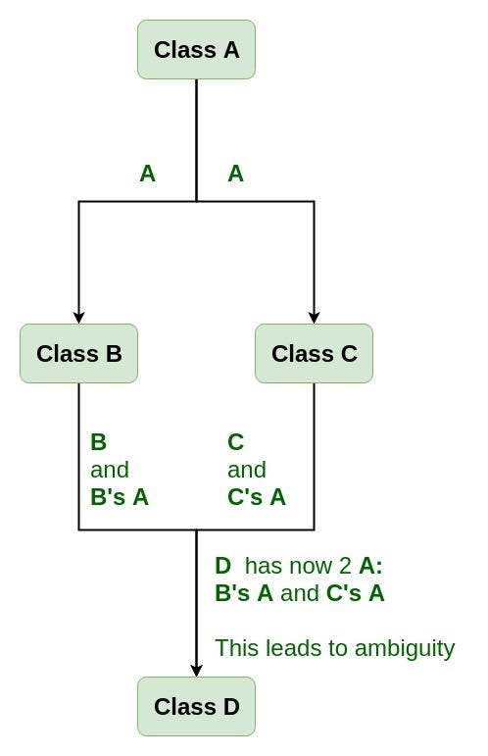
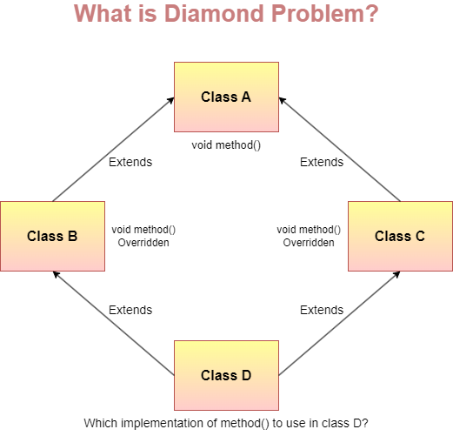
The Diamond Problem happens when:
- A base class is inherited by two classes
- A child class inherits both of them
Structure:
A
/ \
B C
\ /
D

Explanation
- Class A has a method show()
- Class B inherits A
- Class C inherits A
- Class D inherits B and C
Now when D calls show(), the question is:
👉 Should Java use A from B path or A from C path?
This creates ambiguity.

3. Example (Concept Code)
This is allowed in C++ but NOT in Java.
class A
{
void show()
{
System.out.println("Class A");
}
}

class B extends A { }

class C extends A { }

class D extends B, C // ERROR
{
public static void main(String args[])
{
D obj = new D();
obj.show();
}
}
Java compiler gives error:
Multiple inheritance not supported
Because D would get two copies of A.

4. How Java Solves the Diamond Problem
Java does not allow multiple inheritance using classes.
Instead it uses Interfaces.
Example:
interface A
{
void show();
}

interface B extends A {}
interface C extends A {}

class D implements B, C
{
public void show()
{
System.out.println("Hello");
}
}
Here:
- Interfaces don't contain implementation (normally)
- So no ambiguity occurs

5. Diamond Problem with Default Methods (Java 8)
If two interfaces have the same default method, Java forces you to override it.
Example:
interface A
{
default void show()
{
System.out.println("A");
}
}

interface B
{
default void show()
{
System.out.println("B");
}
}

class Test implements A,B
{
public void show()
{
System.out.println("Overridden");
}
}
Java forces override to remove ambiguity.

6. Key Points (Exam Ready)
Concept | Meaning
Multiple Inheritance | One class inheriting multiple classes
Diamond Problem | Ambiguity due to multiple inheritance
Occurs when | Same parent class inherited through different paths
Java Solution | Interfaces instead of classes
Reason | Avoid ambiguity

✅ One-line definition (for exams):
The Diamond Problem occurs in multiple inheritance when a class inherits from two classes that have a common parent, causing ambiguity about which method to use.

If you want, I can also explain Diamond Problem in 20-second exam answer format (very useful for writing in theory papers).

Interface in Java

1. Definition
An Interface in Java is a blueprint of a class that contains abstract methods and constants.
It is used to achieve 100% abstraction and multiple inheritance.
👉 An interface tells what a class should do, but not how to do it.

2. Syntax
interface Animal
{
void sound(); // abstract method
}
A class implements the interface:
class Dog implements Animal
{
public void sound()
{
System.out.println("Dog barks");
}
}
Main class:
class Test
{
public static void main(String args[])
{
Dog d = new Dog();
d.sound();
}
}
Output
Dog barks

3. Important Rules of Interface
Rule | Explanation
Methods are public and abstract by default | No method body
Variables are public static final | They behave like constants
Cannot create object of interface | Animal a = new Animal() ❌
Class uses implements keyword | class Dog implements Animal
Supports multiple inheritance | A class can implement many interfaces

4. Example of Multiple Inheritance using Interface
interface A
{
void show();
}

interface B
{
void display();
}

class Test implements A, B
{
public void show()
{
System.out.println("Show method");
}

public void display()
{
System.out.println("Display method");
}

public static void main(String args[])
{
Test obj = new Test();
obj.show();
obj.display();
}
}
Output
Show method
Display method
Here Test class implements two interfaces, which is multiple inheritance in Java.

5. Interface vs Class
Feature | Interface | Class
Methods | Abstract | Abstract + Concrete
Variables | Constant only | Normal variables
Object creation | Not allowed | Allowed
Inheritance keyword | implements | extends

6. Real-life Example
Think of an interface like a remote control.
Remote control defines:
- Power button
- Volume button
But TV, AC, or Fan implement it differently.

✅ Short exam definition
An interface in Java is a collection of abstract methods and constants used to achieve abstraction and multiple inheritance.

If you want, I can also explain:
- Types of Interface in Java (Java 8 features)
- Marker Interface
- Functional Interface
- Difference between Abstract Class and Interface (very important for exams).

